Maniototo Area School

Charter
2020
'By learning we live'

TIMELINE:
BOT CONSULT: February 2020 SLT CONSULT: Feb 2020 STAFF CONSULT: Feb 2020
PARENTAL CONSULT: April-August 2020 WHANAU CONSULT: May 2020

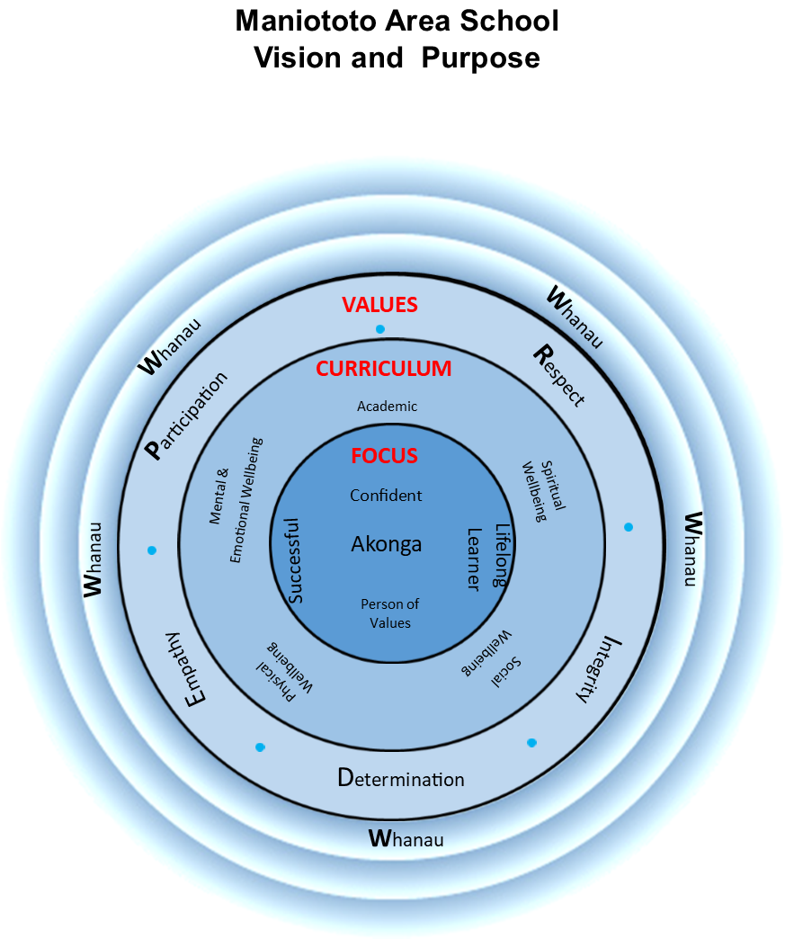

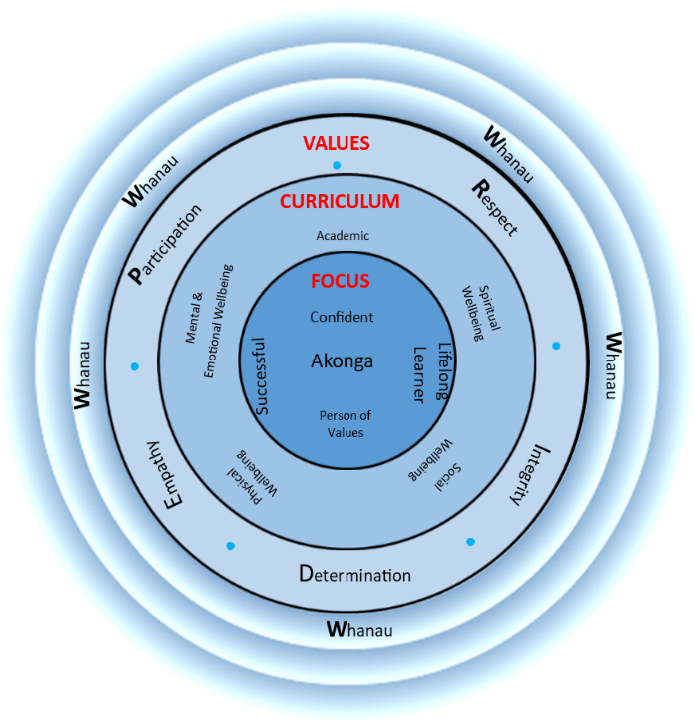
MANIOTOTO AREA SCHOOL STRATEGIC PLAN 2019
Mission – ‘Why we are here’
MAS students will recognise and strive to achieve their potential as skilled lifelong learners and positive, actively involved community members by upholding the school P.R.I.D.E values at all times.
Teaching & Learning
Quality teaching is the most important aspect of our school
Teachers encourage each student to reach their highest possible intellectual, practical, social and recreational abilities
Provide planned and varied learning opportunities in a challenging, caring & stimulating environment
Set high expectations, foster cooperation, responsibility and mutual respect.
Values— ‘How we live’
Our core values guide how we live, and conduct ourselves in our work and our relationships with others in the school. Specifically, our values are:
Participation
Respect
Integrity
Determination
Empathy
Vision— ‘Where we are going’
Through positive influence, example and efforts our students will:
Live the P.R.I.D.E values of the school
Become independent learners
Be confident risk takers
Have regular success
Enjoy school & learning
Be supported and encouraged to develop their physical, mental and emotional, social, and spiritual dimensions of health and wellbeing

Our Strategic Foci at MAS

Hauora
Provide a positive & safe environment where the physical & emotional needs of every student is cared for and nurtured
A socially inclusive school where all students feel safe and happy
Encourage students to be supportive of others and to keep themselves safe in the real & electronic worlds

External focus
Encourage & welcome interest, support and involvement of whanau
Promote school-community partnership
Foster understanding, appreciation and respect for traditional values of the Maniototo and promote good relationships among all cultures
Grow commitment to the Kahui Ako

MISSION: Our Mission statement answers the question ‘Why are we here?’
VISION: Our Vision statement answers the question ‘Where are we going?’ and ‘What do we want to see in our learners?’
VALUES: Our Values relate to ‘How do we act?’. They set out the principles and standards we aspire to.
Our Strategic foci/goals stem from our Vision Statement. They answer the question ‘What are the most important objectives to the current and future health of Maniototo Area School?’

LEVEL ONE: Mission—Vision—Values
UNPACKING OUR STRATEGIC PLAN

LEVEL TWO: Strategic Foci

Teaching & Learning
Teaching & learning is at the centre of what we do.
If we wish to improve outcomes for all students, we must focus on the relationship between the teacher, student, and content. The task that students complete show us how strong the connection is.
It is thus important that our systems and processes are strong and support teaching & learning, and wellbeing.

Our Theory of Action
IF we wish to improve outcomes for all learners
AND teachers have the greatest impact (Teaching matters)
THEN we must focus on instruction above all else

Hauora
In order to improve academic outcomes for all students, we must create a positive, safe, and supportive environment where every student feels cared for and nurtured. We believe that academic success and Hauora complement each other

External Factors
We are a community school. This means that we look to the whanau and the wider community to help us in achieving our mission and vision for all our learners. While being aware of the fact that external factors are quite often outside of the school’s control, we value and appreciate school-community partnership.

LEVEL THREE: Annual Targets

Our Theory of Action
We believe that one or two informed and educated bets are better than simply hedging our bets with low-risk targets.
Each target must be based on evidence (why we need to do this).
So:
1. the target must focus on the instructional core
2. The target must relate to the other areas of focus
3. The target must address identified problems and be visionary at the same time.
4. Everyone takes ownership of the target
2020 Targets
Target #1: Teaching & Learning—
Writing (Yr.1-10): To have 85% of our students reach the expected curriculum levels
At-Risk Students (Yr.1 – 10): To have 50% of identified at-risk students advance at least 2 sub-levels

Target #2: Hauora—
Student Wellbeing: 90% of our students reflect a positive relationship with staff and peers.

Target #3: Involve the wider community in school activities.

At Maniototo Area School, we show PRIDE in the school and ourselves through:

Participation
Being cooperative and contributing.
Taking part with a positive attitude
Being reliable

Respect
Treating others the way you want/the way they want to be treated.
Caring for property & the environment.
Taking care of one's own self.

Integrity
Being truthful to yourself, friends, whanau and community.
Being strong enough to do what is right.

Determination
Using your initiative & persevering when the going gets tough.
Committing to do the best we can.
Kia kaha - be strong

Empathy
Showing aroha towards others
Being kind and tolerant.
Being aware & considerate of people's feelings and culture.

Our Aims and Objectives

Curriculum Delivery | Our parent community believes quality teaching to be the most important aspect of a good school. Our teachers will encourage each student to reach their highest possible intellectual, practical, social and recreational abilities through planned yet varied learning opportunities within a challenging, caring and stimulating environment which motivates, sets high expectations, and fosters cooperation, responsibility and mutual respect. | Each year the Principal and Staff will develop, revise or confirm the curriculum plan in collaboration with the Board. The plan will include specific objectives for curriculum delivery, content, the maintenance of a safe learning environment, and the provision of appropriate guidance and career information for senior students. Focus on our at-risk students will be our main priority.
Curriculum Content | To provide programmes that are responsive to the needs of the time and consistent with the national curriculum, while emphasising core skills of Literacy and numeracy, effective communication, problem-solving, critical and creative thinking, responsible decision making, and good citizenship. | The school's curriculum plan will identify the purposes and key principles of assessing, recording and reporting on student progress and achievement. Emphasis will be on key competencies.
Student Progress  and Achievement | To regularly monitor and report each student's progress, achievements and attitudes in ways that give dependable information about their strengths and next learning steps, enable shared communication and decision making between home and school about learning priorities and goals, and give feedback on the effectiveness and suitability of learning programmes. To increase student's knowledge of their achievements and next steps | Junior School Students (Yr 1-8) have tracking sheets for Literacy and Numeracy. Achievement is also shown on Edge. Students are assessed formatively and summatively and results used to plan programmes and report to parents. Reports are twice yearly. The monthly Attitude reports reflect key competencies through our P.R.I.D.E values and NZC. Yr 3-10 are diagnostically tested with e-asTTle and PAT early in the year and in some areas, re-assessed in Term 4. Year 11-13 are given constant feedback on NCEA progress during the course of the year, including practice exams, internal assessment results and through their strategic planners.
Student Hauora and wellbeing | To provide a positive and safe environment where the physical and emotional needs of every student are cared for and nurtured; an environment which actively seeks to create a socially inclusive school where all students feel safe and happy. To encourage students to be supportive of others and to keep themselves safe in both the real and electronic worlds. | Students are taught the importance of respectful relationships through specific programmes, e.g. through P.R.I.D.E lessons and regular mentoring sessions. The school adopts a proactive stance against any form of bullying. Student feedback is recorded regularly. One period a week, viz. the P.R.I.D.E period is used to actively promote the school values.
Personnel | To be a good employer by acting with fairness and integrity in all employment matters; to promote high standards of staff performance; to support their ongoing professional development, training and conditions of work, and to recognise and value staff initiatives and actions that benefit students and the image of our school. | In consultation with Staff, the Board will prepare policies and plans to appoint quality staff, to reflect its commitment to being a good employer, and to guide the operation of fair, effective performance management systems which enhance teaching and learning. Staff wellbeing is a priority.
Finance | To manage the school's finances to meet current priorities and longer-term goals for the operation and development of our school, and to achieve the best possible conditions and resources for teaching and learning. | The Board will prepare an annual budget to fund the school's curriculum, personnel, and property and administration activities. The Board will monitor and control income and expenditure throughout the year, and ensure the preparation, audit and publication of annual accounts in line with public sector accounting requirements.
Property | To provide safe, hygienic and well-maintained facilities which are suited to the needs of teaching, learning and living, and to plan and make improvements that meet the needs of a progressive curriculum and modern learning environment. | The Board will prepare and implement an on-going plan of the whole-school rebuild and keep in mind provision for safety and hygiene and meeting legislative requirements re hazards. The whole school rebuild due to begin in 2020.
Community Partnership | To encourage and welcome the interest, support and involvement of parents and the wider community in the life of our school and the well-being of our students, and to promote a school-community partnership which benefits from good two-way communications, cooperation, decision making and sharing of talents and resources. | The Board will have a policy with objectives for achieving parent-community support and involvement. The policy will be reviewed and reported on regularly, and revised as the need arises.
Cultural Diversity | To foster understanding, appreciation and respect for traditional values of the Maniototo, and to promote equality of opportunity and good relationships among all cultures represented within our community.  The Board will ensure that all reasonable steps are taken to provide instruction in tikanga Maori and Te Reo Maori for students whose parents request it. NetNZ and Te Kura will be used to provide secondary level programmes in Te Reo. | The school's plans and policies will be developed and implemented in ways that are sensitive to the cultural backgrounds and values of individual children and their families. This includes recognition of the unique position of the Maori people and their culture.  Te Reo and tikanga Maori will be incorporated in school events, programmes and practices and timetabled classes for Te Reo and Kapa Haka.
School  Self-Review | To regularly self-review the performance of the school in relation to this Charter so that achievements can be recognised and priorities identified for school development and improvement.  The BOT will also use ERO Self-assurance statements for self-review. | The Board will have an annual time plan for the ongoing review of its plans and policies, ensuring that each plan and policy defines the procedures for its review. Reports from reviews will form the basis for deciding priorities for school development and improvement.
Special Needs | To offer an inclusive environment for learners with Special Education needs. The BoT will ensure that matters of access to learning and equity are taken into account. Where possible, special needs assistance will be given in the child's own classroom environment. Groups of pupils with identified common needs may be withdrawn from a normal mainstream classroom for specialised instruction. | Individual Education Plans will be written for some children receiving special programmes of instruction. These will be co-written with parents, class/group teacher, RTLB, Special Education Needs Coordinator (SENCO), Support personnel, Teacher Aides and Deputy Principals if appropriate.

STRATEGIC PLAN 2019-2021
Vision: ’Why we are here’
MAS students will recognise and strive to achieve their potential as skilled lifelong learners and positive, actively involved community members by upholding the school P.R.I.D.E values at all times.

Mission: ’Where we are going’
Through positive influence, example and efforts our students will:
Live the P.R.I.D.E values of the school
Become independent learners
Be confident risk takers
Have regular success
Enjoy school & learning
Be supported and encouraged to develop their physical, mental and emotional, social, and spiritual dimensions of health and wellbeing

Values: ’How we live’
Our core values guide how we live, and conduct ourselves in our work and our relationships with others in the school. Specifically, our values are:
Participation
Respect
Integrity
Determination
Empathy

Our Theory of Action: We believe that one or two informed and educated bets are better than simply hedging our bets with low-risk targets.
Each target must be based on evidence (why we need to do this).
So:
1. the target must focus on the instructional core
2. The target must relate to the other areas of focus
3. The target must address identified problems and be visionary at the same time.
4. Everyone takes ownership of the target
2019
Strategic Focus: Teaching & Learning | Strategic Focus: Hauora | Strategic Focus: Whanau
Target(s):  Target #1: Teaching & Learning—What/Why/How  Writing (Yr.1-10): To have 85% of our students reach the expected curriculum levels in the following two aspects of writing:  ⇒ Structure & Language  ⇒ Punctuation  Planned Actions:  Inquiry opportunities for students  Collaborative teaching & learning  Goal setting by students  Self & peer assessment  Numeracy grouping in class  Reading grouping in class  Use of Teacher Aides & special programmes, e.g. ALiM, STEPs  ICT integration  IEP's for Senior students  Daily fitness and PE  Co-Curricular sporting opportunities  Music/Dance/Performing Arts Opportunities  Student self-assessment of key competencies and targeted teaching of KCs  PB4L team to develop the framework and initiate the PB4L approach to pedagogy and behaviour management | Target(s):  Target #2: Hauora—What/Why/How  Student Wellbeing: 90% of our students can share how they are feeling when they need to.  Planned Actions:  Health Programmes – Hauora, Health curriculum  School values and key competencies  Teacher/student relationships  Restorative practices  Mentoring groups  Pastoral care focus  Use of student manager records  Community support agencies  PB4L  Kia Kaha | Target(s)  Planned Actions:
2020
Strategic Focus: Teaching & Learning | Strategic Focus: Hauora | Strategic Focus: Whanau
Specific Target(s):  Writing (Yr.1-10): To have 85% of our students reach the expected curriculum levels in the following two aspects of writing:  ⇒ Structure & Language  ⇒ Punctuation  At-Risk Students (Yr.1 – 10): To have 50% of our at-risk students reach their required level  Planned Actions:  To accelerate the progress of the group of identified at-risk students by at least 2 sub-levels, we will:  - Continue the STEPS literacy programme  - Provide specific grammar programmes  - Provide teacher-aide support  - Create IEPs for the students  - Have diagnostic tests, e.g. Asttle to track progress  - Tracking reflections at set times of the year  Overall general target(s)/goal(s):  Our parent community believes quality teaching to be the most important aspect of a good school. Our teachers will encourage each student to reach their highest possible intellectual, practical, social and recreational abilities through planned yet varied learning opportunities within a challenging, caring and stimulating environment which motivates, sets high expectations, and fosters cooperation, responsibility and mutual respect.  Planned Action(s):  Principal & Staff will develop, revise or confirm the curriculum plan in collaboration with the Board.  We will:  - Provide Inquiry opportunities for students  - Carefully track students  - Continue family-school communication  - Track our Maori students, especially in writing.  - Focus on our Filipino students especially in Literacy  - Continue collaborative teaching & learning  - Encourage goal setting by students  - Continue the Reading Recovery Programme  - Carry on with ALiM & STEPs  - Roll out the Digital Technologies Curriculum  Who is Responsible?  The Principal & Staff, along with students, parents/caregivers, mentors.  Review:  Regular reviews will be carried out by the SMT and Staff. Specific data will be collected in June and December. | Specific Target(s):  Student Wellbeing: (whole school): Students will have enhanced relationships with teachers and each other since this is crucial to and is directly linked with student achievement.  Planned Actions:  We will:  - Conduct a survey in Term 1 and again in Term 4  - Include student feedback at regular intervals through whanau times, student Council, student leadership team meetings  Overall general target(s) goal(s):  Values:  Create a teaching environment that is challenging, ensures values learning and reflects the needs and achievement of the students.  Create Classroom environments that foster mutual and self-respect, cooperation and understanding  Provide an environment which is emotionally and physically safe.  Planned Action(s):  We will:  - Have regular timetabled classes that explicitly teach our P.R.I.D.E values  - Emphasise positive teacher-student relationships  - Continue our restorative practice approach  - Continue with P.R.I.D.E cards, postcards, and other acknowledgements  - Have classroom displays of student work that creates a sense of achievement among the students.  - Increase student involvement in outdoor activities through PE, games and sports, other EOTC activities, camps, and co-curricular and extra-curricular activities.  Who is Responsible?  The Principal, Senior Management Team, staff, student leaders, students.  Review:  A survey will be taken in Term 1 and again in Term 4. Data will be analysed, discussed, and presented to the BoT | Specific Target(s):  Involve the wider community in school activities.  Planned Actions:  We will:  - Hold regular assemblies and performances  - Parent consultations at regular intervals  - Have an Open Day in Term 2  - Have 'meet-the-teacher' afternoon in Term 1  Overall general target(s)/goal(s):  Create a community of learners, by building stronger links between family/whanau, students and school  Planned Action(s):  We will:  - Continue to maintain our facebook page and website  - Have regular newsletters to parents  - Continue to maintain notice boards and screen, celebrating school events and student successes.  - Continue with points mentioned in the specific targets above.  Who is Responsible?  The Principal, SMT, marketing sub-committee, Staff, BoT, PTA  Review:  Regular meetings will be held by the sub-committee. Feedback will be looked at when planning further events.
2021
Strategic Focus: Teaching & Learning | Strategic Focus: Hauora | Strategic Focus: Whanau
Overall general target(s)/goal(s):  Our parent community believes quality teaching to be the most important aspect of a good school. Our teachers will encourage each student to reach their highest possible intellectual, practical, social and recreational abilities through planned yet varied learning opportunities within a challenging, caring and stimulating environment which motivates, sets high expectations, and fosters cooperation, responsibility and mutual respect.  Planned Action(s):  Principal & Staff will develop, revise or confirm the curriculum plan in collaboration with the Board.  We will:  - Provide Inquiry opportunities for students  - Carefully track students  - Continue family-school communication  - Track our Maori students especially in writing.  - Continue collaborative teaching & learning  - Encourage goal setting by students  - Continue the Reading Recovery Programme  Who is Responsible?  The Principal & Staff, along with students, parents/caregivers, mentors.  Review:  Regular reviews will be carried out by the SMT and Staff. Specific data will be collected in June and December. | Overall general target(s) goal(s):  Values:  Create a teaching environment that is challenging, values learning and reflects the needs and achievement of the students.  Create Classroom environments that foster mutual and self-respect, cooperation and understanding  Provide an environment which is emotionally and physically safe.  Planned Action(s):  We will:  - Have regular timetabled classes that explicitly teach our P.R.I.D.E values  - Continue our restorative practice approach  - Continue with P.R.I.D.E cards, postcards, and other acknowledgements  - Have classroom displays of student work that creates a sense of achievement among the students.  - Increase student involvement in outdoor activities through PE, games and sports, other EOTC activities, camps, and co-curricular and extra-curricular activities.  Who is Responsible?  The Principal, Senior Management Team, staff, student leaders, students.  Review:  A survey will be taken in Term 1 and again in Term 4. Data will be analysed, discussed, and presented to the BoT | Overall general target(s)/goal(s):  Create a community of learners, by building stronger links between family/whanau, students and school  Planned Action(s):  We will:  - Continue to maintain our facebook page and website  - Have regular newsletters to parents  - Continue to maintain notice boards and screen, celebrating school events and student successes.  - Continue with points mentioned in the specific targets above.  Who is Responsible?  The Principal, SMT, marketing sub-committee, Staff, BoT, PTA  Review:  Regular meetings will be held by the sub-committee. Feedback will be looked at when planning further events.

Realising Maori Potential

As a result of consultation with our local Maori community, the following courses of action have been adopted to enhance Maori achievement at Maniototo Area School

- Ongoing monitoring and tracking of Maori achievement, but taking care when reporting data that individuals may not be able to be identified
- Ka Hikitia – using specific strategies that further enhance Maori achievement
- Ongoing teaching of Tikanga Maori, Te Ao Maori, & Te Reo Maori in our Junior School and encourage students to be proud of their tikanga
- Sustaining and growing our Kapahaka group
- Encourage strong tuakana-teina relationships
- Teachers are integrating Maori across all curriculum areas. Being aware of Maori perspective

2020
- Continue to promote Te Reo using REAP kaiako, Whaea MaryAnne, continue & strengthen Kapa Haka
- Extend Te Reo instruction in Yrs. 1-8 and via NetNZ at NCEA levels
- Continue to focus on student achievement in line with consultation in 2019. Kahnohi ki kanohi consultation to refine goals and focus areas
- Continue and embed priorities previously identified.

Our Curriculum Annual Plan 2020
Target Area | How will it be addressed? | Responsibility & Timeframe | Outcomes | Cost | Review
Years 1-10 Writing | At least 85% of our students will be at or above required levels. Improvements over previous years will be extended and consolidated. Ongoing moderation will support consistency of judgments. Teacher Aides will support identified students and groups.  At least 50% of identified at-risk students in writing will move at least two sub-levels by the end of the year.  The At-Risk Register will be regularly updated. | Year 1-10 Teachers  Lucia  Joanna  Mid-Year check  &  End of Term 4 | To have 85% achieving at or above the curriculum levels.  50% of students identified as At-Risk move at least two sub-levels | Staffing and Teacher Aide Hours  Additional resources  Additional allowance for teachers to collaborate with other Kahui Ako colleagues.  PLD costs | Principal  SMT  Staff
Student wellbeing | At least 90% of our students will be able to reflect positive relationships with teachers and with each other.  Start of Year Survey and End of Year Survey conducted | Year 1-13 Teachers  PRIDE team  Start of year checkpoint  End of year check | . | Restorative Practices  PLD | SMT  Senior Dean  Form teachers
Maori Target | Maori students who have been identified as Well Below and Below will move at least two sub-levels in one or more of the following areas: Reading, Writing & Maths  Maori students in NCEA will gain at least Level 2 before they leave school. | Year 1-10 teachers  NCEA teachers  Lauren Becker (Maori Coordinator) | Maori students who are well below will move at least two sub-levels | Teacher Aide Hours | SMT  Maori coordinator
School-wide  Achievement of At-Risk Students | Continued participation in our Kahui Ako. A team approach to improving success rates for at-risk students and other goals that the Kahui Ako works on each year.  Close monitoring of at-risk NCEA students will continue through the year.  Consolidation of Tier 1 PB4L will help develop strategies to engage at-risk or underachieving students | Kahui Ako  Teachers  Joanna Brooks (Senior Dean)  Ongoing | Risks to student achievement will be identified earlier, and all teachers will have access to information in all subject areas. Area School teachers will pool expertise.  The leadership team will use data to guide improvement | Indeterminate (see annual budget) | Principal  Leadership Team as per MoE
Year 11-13  NCEA Target | All Year 11-13 students will attain the NCEA level they are attempting. Detailed goals will be developed with students and their families.  We will increase the proportion of students having endorsements in merit or excellence and the numbers of credits passed at merit or excellence  Stronger, clearer course guidance and earlier engagement of families /whanau. | Senior NCEA Teachers  Term 1-4 | Students and whanau will have a shared understanding of student goals and programmes  Success rates will improve to 90% success overall |  | Deputy Principal & Principal

Our Property & Finance Annual Plan 2020

Target Area | How will it be addressed? | Responsibility/Timeframe | Expected Outcome | Cost | Review
Property redevelopment | The rebuild plans are underway.  Staging is being planned in coordination with the Project Manager and architects etc. Work is scheduled to begin mid-2020. | TBIG, Capital Works (MoE) and Baker & Garden Architects  Ongoing | Scheduled construction on Phase 1 to begin mid-2020 and completed end 2020 | To be determined as per MoE | Project Manager, Principal, Rebuild sub-committee
Property management | Playground hazards of lack of safety surfaces and further tree trimming will be prioritised.  Safety during rebuild will be prioritised.  The Horticulture section will be further developed | BoT Property  SLT team  ongoing | Risks from construction work minimised  Resource for horticulture established | TBC | Property Manager, BoT, Principal
Annual Accounts and Annual Audit | Annual accounts, including variance report completed by the due date for approval and audit | Executive Officer  Principal | Public sector accounting expectations will be met
Financial Reporting | For finance subcommittee to prepare monthly reports for BoT that shows financial performance and financial position. | Treasurer  Principal  Executive Officer | The BoT will have a clear understanding on which to base decisions. Priorities will be funded
School Fees/Donations | Ensure that processes are clear, easy to follow and comply with public sector guidelines for schools and Ministry directives recently introduced | Executive Officer | Maintain current rates of payment of donations and fees

Our Community Annual Plan 2020
Area | How will it be addressed? | Responsibility/Timeframe | Outcomes | Cost | Review
Reporting to Parents | Reporting:  The initial report includes student self-assessment, goal setting and parent input. Meet the teacher evenings  Process for establishing OTJ's are refined and clarified for parents/family.  Inclusion of summaries of school-wide and departmental data in school newsletters  Monthly Attitude Reports to parents through Edge | Principals and Teachers  Term 1  Leadership teams  Term 4  Teachers  Term 1, 2, 3 and 4 | Improved communication and partnership.  Families better informed.  OTJ's that are accurate and known by parents.  The relationships between home and school strengthened. | TBC | Principal  SMT
Parent Meetings | Increase the proportion of families attending meetings. Deepen the level to which families are consulted with and have input.  Introduce 'Meet the Teacher' evening, where students share their goals with their teachers and parents present. (each term) | Principal and teachers  Term 1 wk 3, T2 wk 9, T3 wk 10, T4 wk 7  T4 wk 5 for Yr 9-10
School Publicity | Continue sub-committee for school publicity  A screen in foyer showcasing width & depth of curriculum  Newsletters, Notice boards, articles in Positively Maniototo  Burn Radio  School Facebook page and website  Open Day for parents of Yr. 5 to 8 and development of publicity flyers | Principal  Marketing sub-committee  Staff  Students | Ongoing | TBC
Community Consultation | Maori community consultation  Regular' small surveys' to evaluate school programmes and events  Kanohi ki kanohi – take opportunities to ask families/whanau their opinions  Consultation with the wider community | Principal via Lauren, marketing sub-committee & Staff  ongoing  BOT & Principal  SMT | Increased whanau understanding of Neg requirement and knowledge of high school curriculum & student achievement. | TBC | BOT

Our Personnel Annual Plan 2020
Area | How will it be addressed? | Responsibility Timeframe | Outcomes | Cost | Review
Appraisal | Appraisal system aligns with legislative requirements and incorporates RTC, professional standards and the school priorities. Done online through Arinui | Principal  Deputy Principals  Term 1-4 | Good practice will be shared and spread | $100 per Staff
Professional Development | All teachers will participate in the on-going development of PB4L pedagogical knowledge, Restorative Practices  Reflective practices | Leadership Team  In-school Kahui Ako tr. | Increased awareness and consistency of practice | TBC | Principal
Personal Professional Development | Staff will develop their own personal development plan that is part of the performance management system and aligns with school goals. All PLD will be related to the goals in the personal plans & Kahui Ako  Teachers' personal inquiries/reflections based on Kahui Ako cohort groups and topics | Principal  Teachers | Aligned systems will support good teaching practice. PD will support teachers own goals |  | Principal
Good Employer | Board review feedback from surveys to ensure and assess staff morale and wellbeing | Board of Trustees (T3) | Improved staff morale |  | BoT  Principal
Allocation of Units | Ensure the designation of units with Staff. | Principal  Deputy Principals  Term 1 | Allocations will align with school priorities
Kahui Ako Teamwork & Change | Teachers will continue to be supported and encouraged to be responsive to change and to become a more unified team across the Kahui Ako. Senior teachers will increase joint responsibility for student achievement and success – a holistic approach that is student-centred.  Continued CoL participation will address identified challenges  Team effort in SLC supervision and monitoring | Principal  Senior leadership team  In-School teacher |  |  | Principal  SMT  WST

Our Governance Strategy of Self Review

 | Year 1 - 2019 | Year 2 – 2020 | Year 3 – 2021
Term 1 | Annual Plan  Assessment and Reporting  Community Consultation – property redevelopment  English  NCEA results analysis  Kahui Ako – Area Schools community | Annual Plan  Review of Reading, Writing, Maths data for 2019  Charter  Analysis of Variance 2019  Targets for 2020  NCEA results analysis  Curriculum Review – Social Studies | Annual Plan  Review of Reading, Writing, Maths data for 2020  Analysis of Variance  Charter  Targets for 2021  NCEA results analysis  Visual Arts & Music  Kahui Ako-
Term 2 | BOT Self Assurance - Curriculum & Plan  Science  Visual Arts & PB4L  Maori Community Consultation | BOT Self Assurance - Hauora & welfare  Curriculum Review – Woodwork & Graphics, Maths | BOT Self Assurance  Science  Woodwork & Graphics & Woodwork  BOT Self Assurance - Asset Management Ctte  Community Consultation - property redevelopment
Term 3 | BOT Self Assurance Finance Ctte  Social Studies & Mathematics | Technology  BOT Self Assurance Curriculum Review – Science, SENCO, English | Mathematics  Social Studies  Careers  BOT Self Assurance Kahui Ako
Term 4 | Horticulture & Tourism  Reading/ Writing (Yr. 1-10)  Strategic Plan 2020 | Strategic Plan 2021  Curriculum Review – Careers, Music  Reading/Writing (Yr. 1-10) | Careers, Tourism, EOTC  BOT Self Assurance Finance Ctte  Strategic Plan 2022

2020 BOT MEETING DATES (proposed)
Term 1 Wed 12 February & Wed 18 March
Term 2 Wed 20 May & Wed 24 June
Term 3 Wed 22 July & Wed 19 Aug
Term 4 Wed 21 Oct, Wed 18 Nov, Wed 2 Dec

Our Policy Review Cycle
Maniototo Area School has now moved online with School Policies on Schooldocs (www.schooldocs.co.nz)
School policies will be reviewed as per the notifications given by Schooldocs.

 | Policy | Who to consult | 2019 | 2020 | 2021
NAG 1: CURRICULUM | Curriculum & Student Achievement  EOTC  Health Education/Curriculum consultation  Home Learning  Improving Educational Outcomes for Maori  Learning Support  Reading Recovery/Literacy Support  Recognition of Cultural Diversity | Board/staff  Board/staff/parents  Board/staff/parents  Board/Staff/parents  Board/Staff/parents  Board/Staff/parents  Board/Staff/parents | review  review  consult  assurance | review  assurance  review | review  review  assurance
NAG 2:  DOCUMENTATION & SELF-REVIEW | Documentation & Self-Review  Reporting to Parents  School Planning & Reporting | Board  Board/Staff/parents | submit | review  submit | review  submit
NAG 3:  EMPLOYER RESPONSIBILITY | Appointment Procedure  Appraisal of Staff  Appraisal of Principal  Attestation  Classroom Release Time/ Timetable  Complaints  EEO Policy  Employer Responsibility  Performance Management  Police Vetting for Non-Teachers  Protected Disclosure  Provisionally Certified Teachers (PCTs)  Salary Units/Management Allowances  Staff Leave  Teacher Certification and Police Vetting | Board  Board/Staff  Board/Staff/parent  Board/Staff  Board/Staff  Board/Staff  Board/Staff  Board/Staff | assurance  assurance  assurance  assurance  assurance  review  assurance  assurance  assurance | review  assurance  assurance  assurance  review  assurance  review  assurance  assurance  review  review  assurance | assurance  assurance assurance  assurance  review  assurance  assurance  review  assurance  assurance
NAG 4:  FINANCE AND PROPERTY MANAGEMENT | 10 Year Property Plan (10YPP)  Finance and Property Management  Financial Control and Expenditure  SUE (Staff Usage and Expenditure | Board  Board | assurance  review  assurance | assurance  assurance | assurance  review  assurance
NAG 5:  HEALTH, SAFETY, AND WELFARE | Abuse Recognition and Reporting  Alcohol, Drugs, and Other Harmful Substances  Behaviour Management  Child Protection  Digital Technology and Cybersafety  Emergency Planning and Procedures  Evacuation Procedure/Emergency Kit  Harassment  Health, Safety, and Welfare  Medicines, Minor/Moderate injury or illness  Physical Restraint  Risk Management  Safety Management System  Separated Parents, Day-to-Day Care, & Guardianship  Sun Protection  Surrender & Retention of Property and Searches  Visitors | Board/Staff/parents  Board/Staff/parents  Board/Staff  Board/Staff  Board/Staff  Board/Staff  Board/Staff  Board/Staff/parents  Board/Staff | assurance  review  assurance  review  assurance  review  assurance  assurance  assurance  assurance  review  assurance | assurance  review  assurance  assurance  assurance  assurance  assurance  assurance  assurance  review  assurance | assurance  review  assurance  assurance  review  assurance  assurance  assurance  assurance  assurance  review
NAG 6:  LEGISLATION AND ADMINISTRATION | Legislation & Administration Policy  Length of School Year  Privacy  Student Attendance | Board/Staff  Board | assurance  assurance | assurance  review  assurance | assurance  assurance

AREAS OF RESPONSIBILITY (2020) :
Any member may attend any meeting
Committee | Convenor | Members
Professional Ethics | Chairperson | Principal  Staff Rep
Appointments/EEO | Principal  EEO Officer | Belinda Colling  Staff Rep  BoT member
Property/School Houses | Mike Connell (School)  Dave Hutton-Atkins (Houses) | Principal  Chairperson  Craig Paterson
Health & Safety | Principal | Chairperson  Staff Rep  Mike Connell
Finance | Chairperson | Principal  Executive Officer  Craig Paterson
Curriculum | Principal | Staff Rep  Student Rep  All Board Members
PTA | Jenna Huddleston | Staff Rep  Quinton Smith  Belinda Colling
Policy | Principal | Chairperson  Staff Rep  Belinda Colling
School Rebuild | Chairperson | Principal  Craig Paterson  Quinton Smith  Dave Hutton-Atkins  Staff Rep  co-opted member

As per Section 64 of the Education Act, the Maniototo Area School Board of Trustees undertakes to take all reasonable steps to achieve the purpose, aims and objectives in this Charter which have been approved by the Board following consultation with the community in terms of Sections 61 and 63 of the Education Act, and to take full account of the National Education Guidelines and all statutory obligations.
The Board of Trustees accepted this charge as its undertaking to the Minister of Education (Ratified in minutes).
This Charter was submitted to the Ministry of Education for the Minister's approval on 04/3/2020

Chairperson. Board of Trustees _________________________ Date 2/03/2020

For Minister of Education

ANNEX A: CODES OF CONDUCT
(Board of Trustees)

Outcome statement
The Maniototo Area School Board of Trustees will act in an ethical and respectful manner.

Scoping
Every member of the Board will have access to the code of behaviour and have opportunities to discuss its expectations of their conduct. Board business will be conducted in an ethical and respectful manner, in all areas of its responsibilities and authority, in accordance with legislation and board policy.

Expectations and limitations
As members of an effective governance team, each member of the Board of trustees shall:
- ensure the needs of all students, and their achievement is paramount
- be loyal to the school and its mission
- maintain and understand the values and goals of the school
- publicly represent the school in a positive manner
- respect the integrity of the Principal and Staff
- observe the confidentiality of non-public information acquired in their role as a trustee and not disclose to any other persons such information that might be harmful to the school
- be diligent and attend board meetings prepared for full and appropriate participation in decision making
- ensure that individual trustees do not act independently of the Board's decisions
- speak with one voice through board policies and ensure that any disagreements with the Board's stance are resolved within the Board
- in the course of board meetings, disclose any interests in a transaction or decision where they, their family and/or partner, employer or close associate will receive a benefit or gain and leave the meeting for the duration of discussion and/or voting in relation to the matter. (conflicts of interest)
- recognise the lack of authority in any individual trustee or committee/working party of the Board in any interaction with the Principal or Staff
- recognise that only the chair (working within the Board's agreed chair role description or delegation) or a delegate working under written delegation can speak for the Board
- continually self-monitor their individual performance as trustees against policies and any other current board evaluation tools
- be available to undertake appropriate professional development.
Signed Declaration:
I, ___________________________________________________, have read and understood this Code of Behaviour and agree to follow and abide by it to the best of my ability.
_________________________________________ ____________________
(Signature) (Date)

PRINCIPAL

In carrying out his or her duties, the Principal will:

- Ensure that the needs of the students and their learning are given primacy in planning, resourcing and implementing the school's curriculum.

- Show commitment to the belief that each student is of equal value and is entitled to an education which respects their individuality and challenges them to reach their highest standards of personal achievement.

- Be loyal to the Charter and fully committed to achieving its purpose, aims and objectives.

- Act fairly and with integrity in all matters concerning Staff, members of the Board of Trustees, parents and students, and show a commitment to the continuing development of the Staff's professional skills.

- Work cooperatively with school staff, but take final responsibility for decisions within the Principal's authority as delegated by the Board.

- Provide all information on a student to any person with legal rights to the information who requests it, and respect confidentiality by keeping information on students from people who have no right to it.

- Not vote in Board of Trustees' decisions in relation to the Principal's employment.

